2024 SPECIAL CALLED MEETING AGENDAS

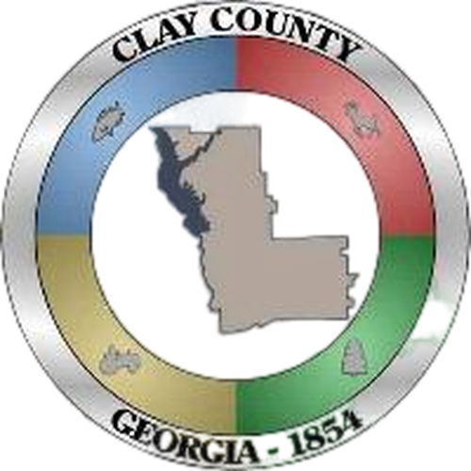
June 4, 2024
Special Called Meeting
6:00 p.m.

1) Call to Order and Opening Prayer

2) New Business
a. Discussion / Approval of Clay County Board of Elections
b. Discussion of Economic Development
c. Discussion of Courtroom Building Plans

3) Adjourn

Public Hearing – FY 2025 Budget
May 28, 2024
6:30 p.m.

1) Call to Order and Opening Prayer

2) Public Comments on Proposed Budget for Fiscal Year 2025

3) Adjourn

Work Session – FY 2025 Budget
April 11, 2024
9:00 a.m.

1) Call to Order

2) Planning- FY 2025 Budget

3) Adjourn

March 19, 2024
Special Called Meeting
6:30 p.m.

1) Call to Order

2) New Business
a. Discussion / Approval of New Clay County Employee Policy Manual
b. Discussion / Approval of Lease or Purchase of Refuse Trucks
c. Discussion of Courthouse Plans

3) Adjourn

January 16, 2024
Special Called Meeting
6:00 p.m.

1) Call to Order

2) New Business
a. Approval of Qualifying Fees for Elected Officials in Clay County
3) Adjourn

January 4, 2024
Special Called Meeting – FY 2024 Millage Rate
6:15 p.m.

1) Call to Order

2) New Business
a. Adoption of Ad Valorem Millage Rate for Fiscal Year 2024
1. Resolution 24-002 Adopting Ad Valorem Millage Rate
2. Resolution 24-003 Designating Use of Insurance Premium Tax

3) Adjourn

