2025 COMMISSIONER MEETING AGENDAS

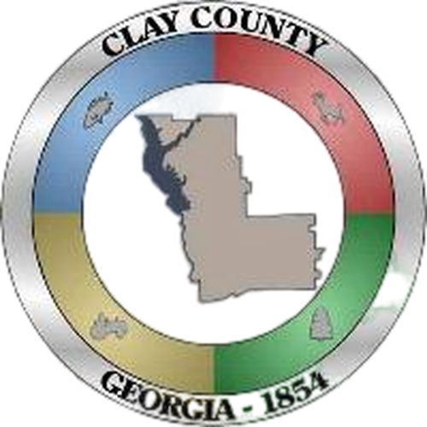

March 4, 2025
Regular Meeting
7:00 p.m.
1) Call to Order and Opening Prayer

2) Agenda Approval

3) Minutes
a. February 4, 2025 Regular Meeting

4) Executive Session (If Needed)
Discussion or deliberation on the appointment, employment, compensation, hiring,
disciplinary action or dismissal, or periodic evaluation or rating of a county officer or employee as provided in O.C.G.A. §50-14-3(6)

5) Continuing Business as a result of Executive Session (If needed)

6) Presentations before the Board

7) Old Business

8) New Business
a. Request Action on Annual Clean-up 2025 March 31-April 12, 2025
b. Request Action on Clay County Sheriff Office Providing Law Enforcement in Fort Gaines.
c. Request Action on Probate Judge Permission to have Three Offices in the Courthouse. Current office, Magistrate Office, and the Election Equipment Office for her Personnel Office.
d. Request Action on Probate Judge having Permission to Purchase Three New Computers.
e. Request Action on Probate Judge having Permission to have a County Paid for Cellphone.
f. Request Action on Probate Judge having Permission to Purchase New Office Furniture.
g. Request Action on Resolution declaring 145 Wilson Street as the Clay County Courthouse.
h. Request Permission for Clay County EMA Director to apply for Hazard Mitigation Grants.
i. Request Action on Agreement between Old Glory Garage and Clay County for County Vehicles Work.

9) Comments from the Public (limited to 3 minutes)

10) Comments from Department Heads & Constitutional Officers
a. Public Works
b. Superior Court
c. Sheriff Report
d. Tax Commissioner
e. Probate/Magistrate
f. Coroner Report
g. Fire Chief Report
h. Chamber Director

11) Administrator Comments, Reports & Recommendations
a. Financial Report
b. Days Avenue CDBG

12) Attorney Status Report

13) Comments from the Board

14) Invoices to Be Approved

15) Adjourn

February 4, 2025
Regular Meeting
7:00 p.m.
1) Call to Order and Opening Prayer

2) Public Hearing
a. Sita Khadkapaudel d.b.a. Georgetown Depot P INC (Ponce Food Mart) - Alcoholic Beverage License Application

3) Agenda Approval

4) Minutes
a. January 7, 2025 Regular Meeting

5) Presentations before the Board
Sasha Owens- Clay County Probate Clerk

6) New Business
a. Discussion/Approval Alcoholic Beverage License Application for Mrs. Sita Khadkapaudel (Ponce Food Mart) Georgetown Depot P INC
b. Discussion/Approval of Resignation from Clay County Georgia Election Board Member Brittany Reynolds
c. Discussion/Approval of Amending FY 25 Budget to include a Clay County Election Board Budget.
d. Discussion/Approval of Clay County Georgia Election Board Supervisor Brittany Reynolds and Vice Supervisor Kendall Crozier
e. Discussion/Approval of Family Connection Fiscal Agent Designation
f. Discussion/Approval of Georgia Forestry Commission Volunteer Fire Assistance Grant Program (VFA)
g. Discussion/Approval of Still Waters Engineering Water Tank Project
h. Discussion/Approval of Paving Wilson Street

7) Comments from the Public (limit to 3 minutes)

8) Comments from Department Heads & Constitutional Officers
a. Public Works
b. Superior Court
c. Sheriff Report
d. Tax Commissioner
e. Probate/Magistrate
f. Coroner Report
g. Fire Chief Report
h. Chamber Director

9) Administrator Comments, Reports & Recommendations
a. Financial Report
b. Days Avenue CDBG
c. Open House New Courtroom February 20,2025 (2:00 p.m. – 4: 00p.m)

10) Attorney Status Report

11) Comments from the Board

12) Invoices to Be Approved

13) Signing of Checks

14) Consent Agenda

15) Executive Session (If Needed)

16) Continuing Business as a result of Executive Session (If needed)

17) Adjourn

January 7, 2025
Regular Meeting
7:00 p.m.
1) Call to Order and Opening Prayer

2) Agenda Approval

3) Annual Appointments
a. Commission Chairman
b. Commission Vice Chairman
c. County Clerk
d. County Attorney
e. County Depository
1. Designation of Signors

4) Minutes
a. December 3, 2024 Regular Meeting

5) Unfinished Business
a. Discussion/Approval of Southwest GA Regional Development Authority and Selection of Two Board Members Edward Watson and Lynthia Alexander

6) New Business
a. Discussion/Approval of Resignation from Clay County Tax Assessor Members Kendall Crozier and Ronald Crozier
b. Discussion/Approval of a Three Member Clay County Tax Assessor Board
c. Discussion/Approval of HB 581 Opt- In or Opt-Out
d. Discussion/Approval of Planning and Zoning Technical Assistance Contract
e. Discussion/Approval of Probation Agreement
f. Discussion/Approval to give Tax Commissioner Authority to take Credit and Debit Cards

7) Comments from the Public (limit to 3 minutes)

8) Comments from Department Heads & Constitutional Officers
a. Public Works
b. Superior Court
c. Sheriff Report
d. Tax Commissioner
e. Probate/Magistrate
f. Coroner Report
g. Fire Chief Report

9) Administrator Comments, Reports & Recommendations
a. Financial Report
b. Days Avenue CDBG

10) Attorney Status Report

11) Comments from the Board

12) Invoices to Be Approved

13) Signing of Checks

14) Consent Agenda

15) Executive Session (If Needed)

16) Continuing Business as a result of Executive Session (If needed)

17) Adjourn

